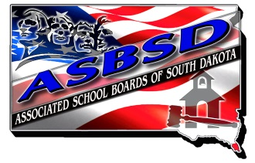
Delegate Certification Form

2015 Delegate Certification

Associated School Boards of South Dakota Constitution and Bylaws (Article V, Section 3, Subsection [b]) provides every school board, which is a member of the Corporation, may appoint one of its members to act as an official delegate to the annual assembly.

A voting delegate must be a school board member serving on a school board in good standing with its dues paid for the current year.

We hereby certify that the following is our voting delegate and alternate to the 2015 ASBSD Delegate Assembly in Pierre, South Dakota, November 20, 2015.

Delegate:

___________________, _______________________________
(Name) (Complete home mailing address)

Alternate:

___________________, ________________________________
(Name) (Complete home mailing address)

_________________________ _______
(School District)

________________________________
(Board Chairperson’s Signature)

To assist in meeting preparations, ASBSD has established an administrative Oct. 23 deadline for delegate certification. However the deadline established in the Constitution and Bylaws is 10-days prior to assembly, which is November 10.

Return this form to:
Katie Mitchell-Boe, Executive Secretary
Associated School Boards of South Dakota
PO Box 1059
Pierre, SD 57501-1059
or via fax at 605.773.2501
or via email at Katie@asbsd.org

