Superintendent Evaluation
A Resource for School Board Members and Superintendents

Associated School Boards of South Dakota
School Administrators of South Dakota
August 2015

INTRODUCTION

This guide, along with the supporting resources, is designed to help school board members and superintendents implement an effective, meaningful superintendent evaluation process that is focused on improving student achievement.

The resources referenced in this publication were developed jointly by Associated School Boards of South Dakota and School Administrators of South Dakota with the help of a panel of superintendents who offered valuable input, insight and direction.

All resources are based on professional performance standards for superintendents, as developed by the Interstate School Leaders Licensure Consortium (ISLLC). The state’s higher education institutions use the same standards to structure academic coursework for superintendents.

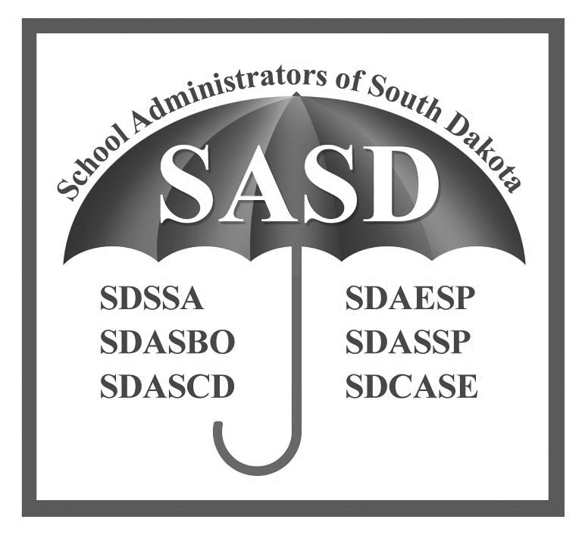

for more information
Associated School Boards of South Dakota
Wade Pogany, Executive Director
605.773.2500 [phone]
wpogany@asbsd.org [e-mail]

School Administrators of South Dakota
Rob Monson, Executive Director
605.773.2525 [phone]
rob.monson@sasd.org [e-mail]

overview

Evaluation of a superintendent’s performance is one of the school board’s most important responsibilities.

At the most basic level, an evaluation helps the board make informed employment decisions. Done correctly, an evaluation is a useful governance tool that helps drive school improvement. In fact, a high quality evaluation process helps develop positive board-superintendent relationships, clarifies leadership roles, creates common understanding, and provides a mechanism for public accountability.

To achieve the most from your district’s evaluation process, the school board and superintendent need to arrive at a mutual understanding of expected performance and acceptable evidence that demonstrates that performance. It is also important to keep in mind that evaluations are most effective when they are designed and used for communicating future expectations, not simply for reviewing past performance.

WHY EVALUATE THE SUPERINTENDENT?
A quality superintendent evaluation process provides benefits for the community, school board and superintendent. An evaluation process:

- Provides oversight and assurance, through the public’s elected representatives, that policies and community priorities are being effectively implemented;
- Allows school board members to follow district progress and learn about a superintendent’s ongoing professional growth; and
- Provides input and feedback to the superintendent to help him or her improve throughout the school year.

How do we evaluate objectively and fairly?
Every evaluation process will include some level of subjectivity, but using effective tools and procedures will make the process more objective.

- Documentation. An evaluation is more than a checklist – it requires the careful consideration of supporting documentation, or evidence, to decide whether expectations have been met.
- Standards and Ratings. An effective evaluation requires board members to rate performance relative to agreed-upon standards. Completing the evaluation is easier if each standard is linked to understandable performance indicators that board members can consider when determining overall ratings.
- Written Comments. Written comments clarify the evaluation, providing the board an opportunity to deliver specific constructive criticism and praise. Written comments also provide the superintendent with useful information that he or she can use to continually improve.
- Evaluation Conferences. Face-to-face meetings between the board and superintendent are essential. Meetings should occur to discuss evaluation standards, establish goals, determine the evaluation instrument and process, present supporting evidence, and to discuss the results of the board’s year-end evaluation.

RESOURCES
The resources provided are sample documents. School boards and superintendents may elect to modify the various components to best fit the needs of the district.

EVALUATION OPERATING PRINCIPLES
Operating principles provide a road map for structuring an effective superintendent evaluation by outlining the purpose and outcome underlying the entire process.

TIMELINE FOR SUPERINTENDENT EVALUATION
A thoughtful superintendent evaluation is an ongoing process that produces constructive dialogue regarding the chief administrator’s performance. The sample timeline presents a suggested schedule that breaks evaluation into small steps to be completed throughout the year.

standards-based evaluation
The sample end-of-year evaluation is based on the ISLCC superintendent standards, complete with sample performance indicators, that act as a basis for evaluation. The instrument also is designed to allow board members to offer commentary and direction for improvement.

GOALS-based evaluation
The goals-based evaluation, which can be used separately or together with a standards-based evaluation, establishes a framework to help boards and superintendents establish district-level goals and then evaluate the progress made toward those goals. In addition to the evaluation instrument, the resource also includes sample goals to illustrate how a goals-based evaluation may look.

SUPERINTENDENT JOB DESCRIPTION
The sample superintendent job description is based on the ISLCC professional performance standards for superintendents and articulates the functions of the district’s chief administrator.

SUPERINTEDNENT PROFESSIONAL DEVELOPMENT PLAN
This worksheet allows a superintendent to document personal and professional goals that are linked to the model superintendent performance standards. The resource is intended to allow the board and superintendent to acknowledge, track and recognize professional growth and continuous improvement.

FIND IT ONLINE: ACCESS SUPERINTENDENT EVALUATION RESOURCES
The resources referenced are available for download on ASBSD’s website.
- Visit http://www.asbsd.org
- Click on the Publications & Forms page link at the top of the homepage.
- Scroll down to the Superintendent Evaluation section
- Select the document you wish to use.

The ASBSD Publications & Forms page can be accessed through www.sasd.org, as well.

