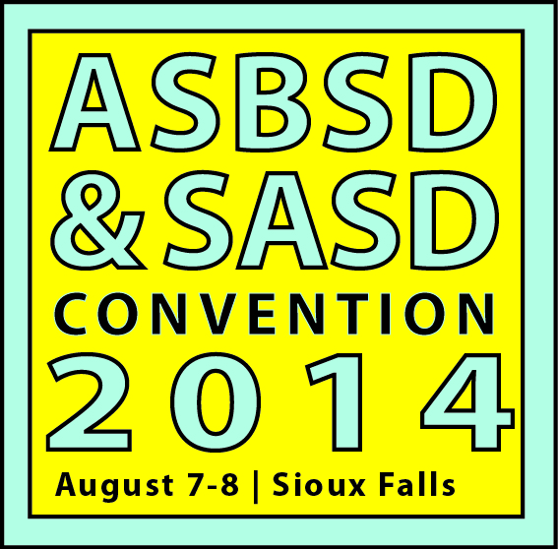
ASBSD AND SASD CONVENTION PROPOSAL SUBMISSION FORM
Interested in sharing your expertise with education leaders?
Fill out the proposal form below and email it to tpickner@asbsd.org by Monday, April 21, 2014.
A standard break-out session is 50 minutes long, but ASBSD and SASD will consider proposals for two-hour, in-depth presentations. Individuals will be notified once programming decisions are made.

Session Title:

Presenter(s): (full name, title and organization you represent)

Contact Information: (email and phone number, only one contact name needed)

Scheduling Preference: (optional, designate a time slot preference)
Thur., Aug. 7 - Morning Thur., Aug. 7 - Afternoon Fri., Aug.8 – Morning

Session Description: (75 words or less)

