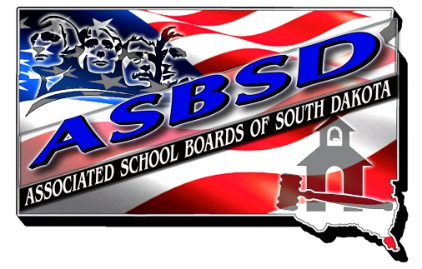

ASBSD School Board Award of Excellence

OVERVIEW

Associated School Boards of South Dakota is committed to recognizing the dedication and leadership of South Dakota School Boards. The School Board Award of Excellence will be given annually to a public school board which consistently demonstrates outstanding leadership that enhances the achievement for all students.

To earn the award, a school board must have demonstrated governance leadership in promoting excellence in public education.

ELIGIBILITY: All public school boards that are members of Associated School Boards of South Dakota in good standing are eligible. School boards may be nominated by a staff member, a community member or by the board.

SELECTION PROCESS: Screening and final judging will be done by a (5 to 7 member) panel of school board members, educators and business community members established by the ASBSD Board of Directors.

AWARD AND RECOGNITION: The board will be identified and recognized at their local district and at the ASBSD and SASD Convention. A plaque and a scholarship award of $1,000 will be presented to the recipient board. The $1,000 cash award may be used, at the discretion of the board, for board learning and development, a scholarship to a student of the board’s choice, or any other purpose to promote the district’s vision.

TO APPLY: An application form and information can be found on the ASBSD website. Applications for the 2016 school year must be postmarked or delivered electronically to the ASBSD office on or before June 17, 2016 to:

Katie Mitchell-Boe
Associated School Boards of South Dakota
PO Box 1059
Pierre, SD 57501
katie@asbsd.org
2016 School Board Award of Excellence Application

APPPLICATION INFORMATION

District Name: __________________________________________________________________________________________
Board President: ______________________________________________________________________

Years of Board Experience:________
Email: _________________________
Phone:_________________________

Vice-President: _______________________________________________________________________

Years of Board Experience:_________
Email:__________________________
Phone: _________________________

Board Members’ Name: Years of School Board Experience:

__________________________________________ _______________
__________________________________________ _______________
__________________________________________ _______________
__________________________________________ _______________
__________________________________________ _______________
__________________________________________ _______________
__________________________________________ _______________

Superintendent: ______________________________________________________________________

Email: __________________________

Phone: _________________________

APPLICATION DIRECTIONS:

- Complete the cover page with the information requested.

- Answer the five questions in 3 pages or less. Use examples and/or data if possible to illustrate the board’s accomplishments and activities.

- Please provide one letter of endorsement from the community in support of the board application, and one letter of support from the superintendent.

SELECTION QUESTIONNAIRE:

Consideration for the award will be based on responses to the following questions. On a separate sheet, please submit your responses and include with your application.

- What high expectations and goals has your board set in recent years?
- What are your most significant achievements you have accomplished in reaching your goals?
- What has your board done to improve student achievement in your district?
- What has your board done to improve the leadership, teamwork and decision making skills of your board members?
- What has your board done to improve communication between your superintendent, staff, community and the board?

EVALUATION PROCESS AND SELECTION COMMITTEE CONSIDERATIONS

- All applications will be reviewed by ASBSD staff for compliance with directions; incomplete applications will be removed from consideration.
- The selection process will use a blind screening method, which means the district name and other identifying names will be blocked-out during screening. The name of the successful district will be identified after a selection is made.
- The selection committee will include five to seven members. Potential Selection Committee may include:
  - President or vice president of ASBSD
  - Two past or current members of the ASBSD Board of Directors - One east river and one west river
  - Member of the State Board of Education or Department of Education
  - South Dakota’s current outstanding superintendent

SCORING

- Complete the cover page with the information requested. (5 pts)

- Questionnaire responses (15 points per question = 75 pts)

- Two letters of endorsement in support of the board application. (20 pts)

Questions, please contact ASBSD Executive Secretary Katie Mitchell-Boe via email at Katie@asbsd.org or by phone at 605-773-2502.

