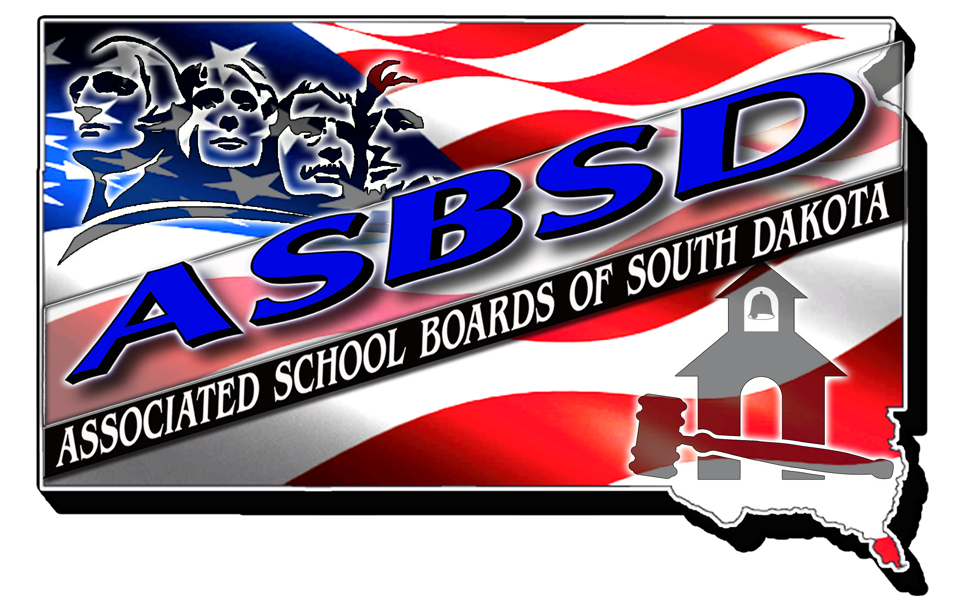

ASBSD COMMUNITY SERVICE AWARD

BASIC QUALIFICATIONS

The ASBSD Community Service Award is presented to individuals or groups serving their local school district in exemplary fashion.

Award nominees have shown personal involvement to improve the quality of South Dakota public education in one or more of the following areas:

- Provides community leadership focused on enhancing the achievement of all students.

- Enhances the safety and welfare of children.

- Champions the education of the whole child in support of arts, music and co-curricular programs for all students.

- Works collaboratively with the school board on fund raising activities.

- Involved in the renovation or construction of quality educational facilities, landscaping, playgrounds or equipment.

- Involved in the acquisition of appropriate, adequate and quality learning materials to support student learning.

- Recognized as a community leader committed to supporting our school community.

ASBSD COMMUNITY SERVICE AWARD NOMINATION FORM

The following information is for office use only. ASBSD will prepare a summary biography to appear in the bulletin and the convention program.

Please be certain the nomination is well documented and does justice to the contributions of the nominee.

Nominees Name:_____________________________________

Address:___________________________________________

1. Provides community leadership focused on enhancing the achievement of all students.

2. Enhances the safety and welfare of children.

3. Champions the education of the whole child in support of arts, music and co-curricular programs for all students.

4. Works collaboratively with the school board on fund raising activities.

5. Involved in the renovation or construction of quality educational facilities, landscaping, playgrounds or equipment.

6. Involved in the acquisition of appropriate, adequate and quality learning materials to support student learning.

- Recognized as a community leader committed to supporting our school community.

8. Major contributions to school programs OR other pertinent information and activities

Nomination submitted by: ____________________________

THIS NOMINATION MAY BE MADE BY ANY INDIVIDUAL OR ANY GROUP OF INDIVIDUALS IN ANY SCHOOL COMMUNITY IN SOUTH DAKOTA.

PLEASE RETURN NO LATER THAN Tuesday, July 2, 2019.

PLEASE MAIL ENTRY TO: ASBSD
PO Box 1059
Pierre, SD 57501-1059

OR

E-MAIL SUBMISSION TO katie@asbsd.org

