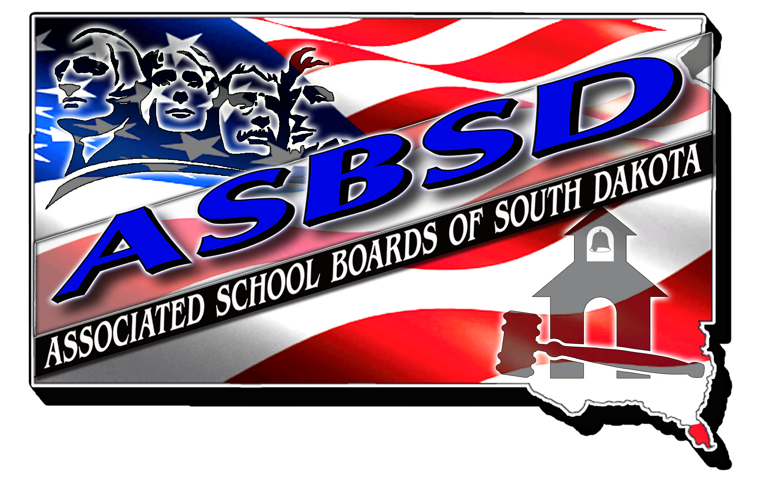

**ASBSD INVITES NOMINATIONS FOR**

**SCHOOL BELL AWARD**

**BASIC QUALIFICATIONS**

The following guidelines are helpful in the nomination and selection of individuals who merit the ASBSD School Bell Award. A specific requirement for this nomination is that the citation must be in recognition of the individuals work to improve public education in South Dakota.

**AN INDIVIDUAL NOMINATED FOR THE ASBSD SCHOOL BELL AWARD HAS CONTRIBUTED STATEWIDE TO ENHANCING THE QUALITY OF K-12 EDUCATION IN ONE OR MORE OF THE FOLLOWING AREAS:**

1. Consistently promotes the welfare and achievement of children of South Dakota’s K-12 children.
2. Has worked to secure and provide quality facilities and equipment.
3. Has worked to secure quality teaching and learning.
4. Has worked toward the introduction and passage of legislation to enhance K-12 education opportunities.
5. Has worked toward the provision of adequate funding for K-12 education in South Dakota.
6. An individual who stands out as a leader for improving public K-12 education in South Dakota.



**SCHOOL BELL AWARD**

**NOMINATION FORM**

The following information is for office use only. ASBSD will prepare a summary biography to appear in the bulletin and the convention program.

Please be certain the nomination is well documented to do justice to the contributions of the nominee.

Nominees Name:____________________________________

Address:___________________________________________

1. Consistently promotes the welfare and achievement of South Dakota’s K-12 children.

2. Has worked to secure and provide quality facilities and equipment.

3. Has worked to secure quality teaching and learning.

4. Has worked toward the introduction and passage of legislation to enhance K-12 education opportunities.

5. Has worked toward the provision of adequate funding for K-12 education in South Dakota.

6. An individual who stands out as a leader for improving public K-12 education in South Dakota.

7. Major contributions to school programs OR other pertinent information and activities:

Nomination submitted by: ____________________________

**THIS NOMINATION MAY BE MADE BY ANY INDIVIDUAL OR ANY GROUP OF INDIVIDUALS IN ANY SCHOOL COMMUNITY IN SOUTH DAKOTA. PLEASE RETURN NO LATER THAN THURSDAY, JULY 1, 2021.**

**PLEASE MAIL ENTRY TO: ASBSD**

**PO Box 1059**

**Pierre, SD 57501-1059**

**OR E-MAIL ENTRY TO: katie@asbsd.org**