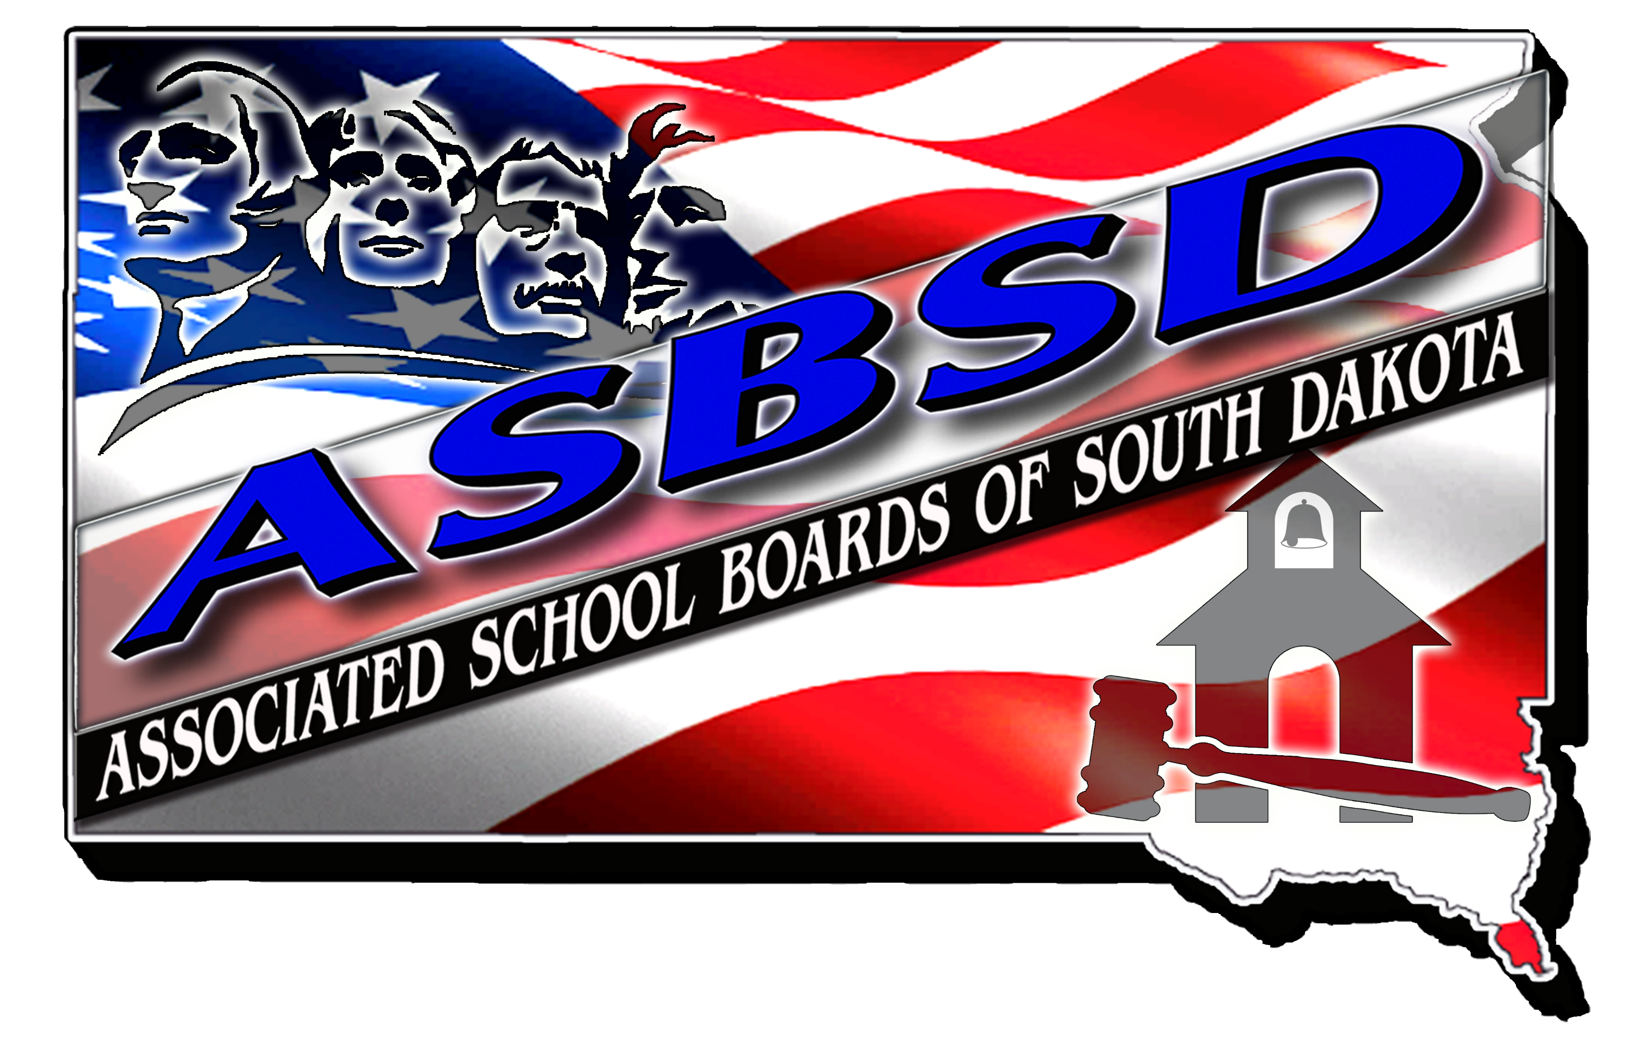

ASBSD Member Services Coordinator

General Position Description:
How can ASBSD better meet the needs of local school boards and superintendents? This position will coordinate and promote all aspects of membership services among the various departments within ASBSD. Communication with local school boards and superintendents is a vital part of the service ASBSD provides. Assisting with marketing member services from the Director of Protective Trust, Director of Communications, Director of Policy and Legal Services, and Director of Board Development in marketing ASBSD programs will be the primary focus.
Essential Job Expectations:
Position Summary: Provides marketing services for the Health, PL, WC members by engaging with educating school districts on the benefits of insurance pooling along with other services offered by ASBSD. Provide communication services, including marketing, web work and social media duties, for ASBSD events and services directed at Association members.
Qualifications:
- Minimum BS or BA.
- Five years of experience within a K-12 educational facility (preferred).
- Working knowledge of the insurance industry.
- Proficient in the use of Microsoft programs Excel, Word and Access and Publisher.
- Familiarity with Wordpress CMS.
- Knowledge of Adobe programs, including Reader, InDesign and Photoshop.
- Experience using various social media platforms, including Facebook and Twitter.
- Excellent organizational skills and multi-task/project management skills.
- Excellent written and oral communication skills with attention to details.
- Must be able to work independently.
- Valid driver’s license.

Essential Functions Protective Trust:
Work directly with the Director of Protective Trust Services to:

1. Strategize, create, and implement marketing campaigns that support development and growth of each fund.
2. Elevate the marketing efforts through brand awareness that supports lead generation and conversion.
3. Maintains database of all marketing calls.
4. Request and obtain required information to allocate premiums for proposal.
5. Initiate updates to marketing materials/website as offerings change and adapt to market.
6. Present at local, regional and state meetings, as needed.
7. Prepares and delivers presentations to member districts.
8. Provides timely responses and follow-up to member or potential member inquiries.
9. Understands policies to assist with basic questions regarding claims, coverage and options of the three funds.

Essential Functions Communications:
Works directly with the Director of Communications to:

- Assist in or create marketing materials (email notices/blog posts/other material) for events and services of ASBSD.
- Contribute blog posts for the ASBSD Blog and Blog Brief.
- Help maintain and update the ASBSD and Conventions websites.
- Generate posts for and moderate ASBSD social media platforms.
- Support development of the Association’s communications calendar.
- Develop marketing strategies for all ASBSD products including, Quorum, BuyBoard, Online policy services.

Associated Functions:

- Follow ASBSD policies, procedures and Staff Operating Principles.
- Make good use of association resources.
- Able to work with confidential information.
- Able to occasionally lift and/or carry materials or equipment over 40 lbs.
- Able to walk up and down stairs while lifting equipment.
- Valid driver’s license.
- Perform other duties as assigned for the efficient and effective operation of the Association.
- Able to obtain state insurance licensure in areas of fund coverages.

Knowledge, Skills and Abilities:
- Able to communicate information clearly and concisely.
- Able to speak in front of small and large groups.
- Able to design and deliver presentations.
- Able to shift gears quickly to respond to different situations.
- Able to make critical decisions without direct supervision.
- Able to sit/stand and operate a computer for extended periods of time.
- Able to travel for extended periods and on short notice.
- Knowledge of applicable state and federal laws related to ASBSD products and services.
- Knowledge of each fund insurance coverage.
- Knowledge of risk management fundamentals.
- Knowledge of safety and loss control policies and procedures.
- Able to be away from home for extended periods of time.
- Service-oriented with positive attitude.

Anticipated outcomes for the position
Increased exposure of ASBSD brand, products and services with member schools.
Collect feedback and report on needs of membership.
Coordinate information communicated to members.
Increase participation from schools in ASBSD products, services and trainings.

