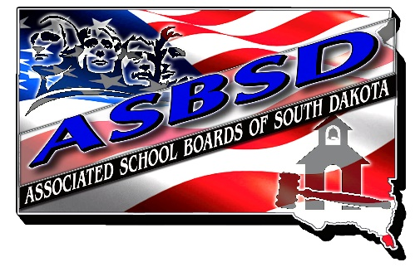

ASBSD INVITES NOMINATIONS FOR
OUTSTANDING SCHOOL BOARD MEMBER OF THE YEAR

BASIC QUALIFICATIONS

Each year ASBSD honors a South Dakota school board member who exemplifies extraordinary leadership of public education as the Outstanding School Board Member of the Year.

Any school board member may be nominated for the award.

An outstanding board member is one who:

- Stands firm for the achievement, welfare and safety of all students. His or her activities point to a long-range program for improving educational opportunities for all children.

- Communicates a belief and expectation that all students can achieve at a high and equitable level.

- Insists on securing and retaining quality staff and supports professional development to strengthen the quality of instruction and achievement levels of all students.

- Works with other board members and the superintendent to establish a district-wide understanding and commitment to student achievement goals.

- Supports district-wide goals for improving student achievement during budget preparation, adoption and implementation.

- Consistently supports board policy, majority decisions of the board and staff members in carrying out board decisions.

- Reaches out to community groups, public and private agencies and the business community to benefit students.

- Advocates securing financial resources to fund adequate education programs to meet district goals through school board leadership.

- Nominee must be an active board member at the time of receipt of the award.

OUTSTANDING SCHOOL BOARD MEMBER OF THE YEAR
NOMINATION FORM

The following information is for office use only. ASBSD will prepare a summary biography to appear in the bulletin, convention program and to accompany media releases. Please submit a photo of the nominee along with the application.

Nominee’s Name: _________________________________ Address: ___________________

Place of Birth: ____________________________________ DOB: ______________________

Education Level: __________________________________ Occupation: _________________

Family: ______________________________________________________________________

____________________________________________________________________________

Personal interests: _____________________________________________________________

____________________________________________________________________________

School District: ___________________________________ Dates of Service_______________

Positions held on local school board: ______________________________________________

Other leadership positions held: __________________________________________________

Please briefly explain how the nominee fulfills each criterion:

- Stands firm for the achievement, welfare and safety of all students. His/her activities point to a long-range program for improving educational opportunities for all children.

- Communicates a belief and expectation in that all students can achieve at a high and equitable level.

- Insists on securing and retaining quality staff and supports professional development to strengthen the quality of instruction and achievement levels of all students.

- Works with other board members and the superintendent to establish a district-wide understanding and commitment to student achievement goals.

- Supports district-wide goals for improving student achievement during budget preparation, adoption and implementation.

- Consistently supports board policy, majority decisions of the board and staff members in carrying out board decisions.

- Reaches out to community groups, public and private agencies and the business community to benefit students.

- Advocates securing financial resources to fund adequate education programs to meet district goals through school board leadership.

- Other pertinent information/activities:

Nomination submitted by: ____________________________

This nomination may be made by any individual or any group of individuals in any school community in South Dakota. Up to three letters of recommendation may be submitted.

PLEASE RETURN NO LATER THAN WEDNESDAY, JULY 1, 2026 by mail to: ASBSD, PO Box 1059, Pierre, SD 57501-1059 OR by email to Katie@asbsd.org.

